Course: IT 58 Emerging Technologies in HCI
Instructor: May Marie Talandron-Felipe
Date Submitted: Mar 21, 2026

Pest and Disease Advisory Module: AI Decision Support for Rice Farmers
Group Members:
Archie, Jiffy G.
Magdaraog, Emmanuel B.
Miñao, Jazerei Mikaella C.
Pulmones, Janmarc
Salapang, Earl Angelo

1. Project Summary
The proposed project is the construction of an AI-based advisory system that will assist rice farmers in recognizing pests and diseases in their plants at an early stage by the use of the image recognition technology. The system will assist farmers in achieving faster and better informed decisions to save their crops and enhance the production of agriculture goods.

2. Background of the Problem
Farming of rice is extremely significant in feeding millions of individuals on top of the livelihood of rice farmers. Nevertheless, rice farms are susceptible to pests and diseases on plants which damage the crops, lower yields of harvest, and raise farm operation expenditures.
Numerous farmers, particularly in the rural fields, are unable to easily access agricultural experts that would assist them in detecting the problem with crops early enough. Due to this, pests and diseases would be able to spread at a great pace and inflict great damage before farmers could take measures. Due to an ongoing advancement in technology, this challenge can be addressed with the aid of artificial intelligence that will supply the farmers with automated systems that aid them in the rapid detection of crop diseases and pests. Listing the potential health problems of plants, farmers can easily identify them with the help of AI-based image recognition and be offered an immediate solution to treat and prevent them.

3. Target Users
The following are the main users of the system:
- Rice farmers especially small-scale farmers who have little access to agricultural experts
- Agricultural technicians and extension workers to help the farmers manage their crops
- Farm cooperatives and agricultural organisations that are supportive of rice production
These groups of users can benefit from a system to provide fast accessible and easy to understand crop health advice.

4. Proposed AI Solution
The proposed system is the artifical intelligence (AI)-enabled Pest and Disease Advisory Module that assists farmers with identification and control of the problems of rice plants through image recognition and machine learning.
The system will enable farmers to take a photo of a rice plant with signs of pest damage or disease on it via a mobile phone or digital device. The AI model will then analysis the image and identify the possible pest or diseases affecting plant.
After analyzing the image, the system will give advisory information including:
- Identification of the pest or Total disease
- Recommended treatment practices
- Prevention strategies
- Farming Practices that are recommended
This solution encourages farmers to take immediate action and prevents they face a high risk of having their crops getting drastically damaged.

5. Human-Centered Features
The system is to be simple, accessible and useful for farmers - even the least technical ones.
Important human-centered features are:
- Easy Image Capture
Farmers can just capture a picture of a rice plant using their mobile phone.
- Automatic Detection of Diseases
The AI system automatically interprets the image without the need for user's technical input.
- Clear and Workable Recommendations
The system offers advice that is easy to understand and implement right away by the farmer.
- Mobile Accessibility
The system can be used on mobile devices, which is convenient for farmers who can access information directly from their fields.
- Quick Decision Support
Farmers can get real-time guidance rather than relying on the manual inspection of experts.

6. Expected Benefits
The project is expected to generate a number of positive impacts to farmers and the agriculture sector.
- Early detection of the problems in the crop
Farmers have an opportunity to detect pests and diseases at an early stage to stop their spread.
- Reduced Crop Loss
Quick responses to health issues of plants can help in minimizing damage and improving the harvest yield.
- Improved Productivity
Better crops mean better quality rice crop and increased farmer's income.
- Accessible Agricultural Information
Farmers are getting access to expert-level advice via technology.
- Support for Sustainable Agricultural practiced on the farm
The system promotes improved farming and best pest management efforts.

7. Initial Data Requirements
To develop the AI system, several types of data will be needed.

Type of Data Needed
- Images of rice plants
- Images of rice pests
- Images of disease of rice plants
- Comparative images Healthy rice plants images
- Information regarding treatments and prevention techniques

Possible Data Sources
- Research institutions involving agriculture
- Public ag data decals (datasets)
- Government agriculture dept.
- Universities performing the agricultural studies
- Images collected given proper permission from farms

8. Simple System Idea / Workflow
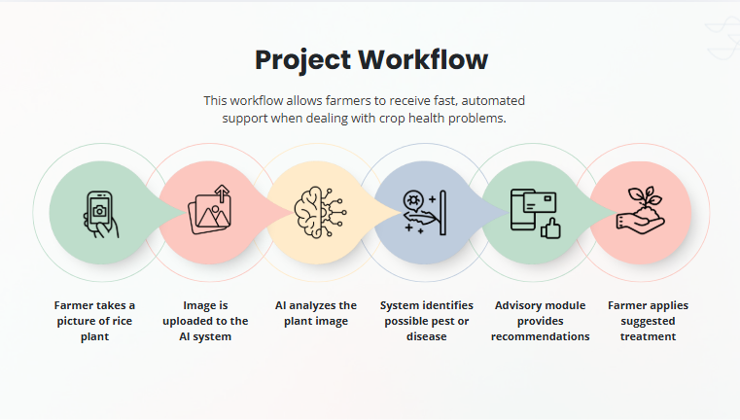
The system will follow a simple step-by-step process:

